### Example assessment questions for deploying a keyword spotting system

Question

Cascade architectures (also known as “multi-stage inference”) allows for the deployment of large models to microcontrollers.

1. True
2. **False**

Explanation: cascade architectures break larger problems into smaller, multi-stage models, which can help improve accuracy and save on memory.

Question

You deploy a trained model to your embedded system. The model gives us 4 outputs, each corresponding to the probability of each class. How do you identify the predicted class?

1. Sum the probabilities together and divide by 4
2. Choose the class with probability over a threshold
3. Choose the class with the lowest probability score
4. **Choose the class with the highest probability score**

Question

You wish to choose a threshold for your classification system, so you create 2 histograms on the same plot: one for the output probabilities of your target class when the input is your target class and another when the input class is not the target class. You get the following:

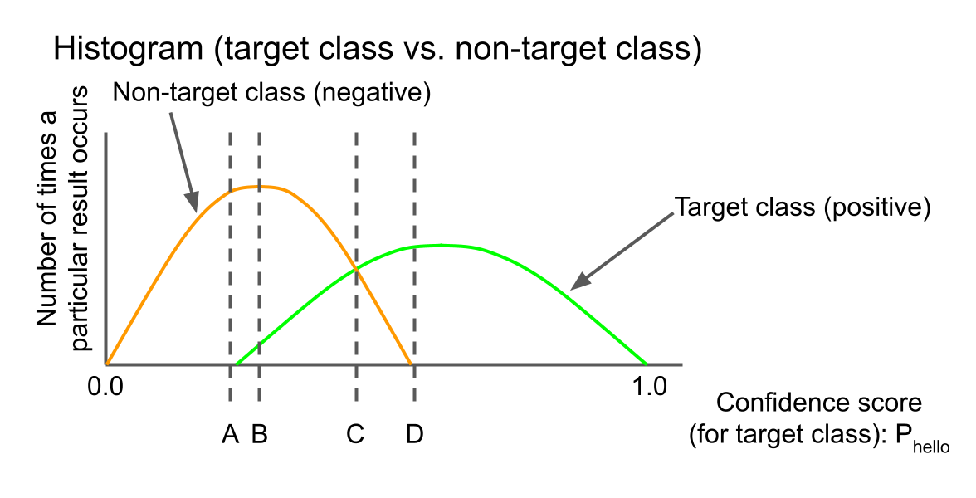

Which threshold should you choose if you want to minimize false negatives?

1. **A**
2. B
3. C
4. D

Question

You use the same validation dataset to evaluate 4 different models, which produce the ROC curves given below. Which model is likely to give you the best accuracy for your application?

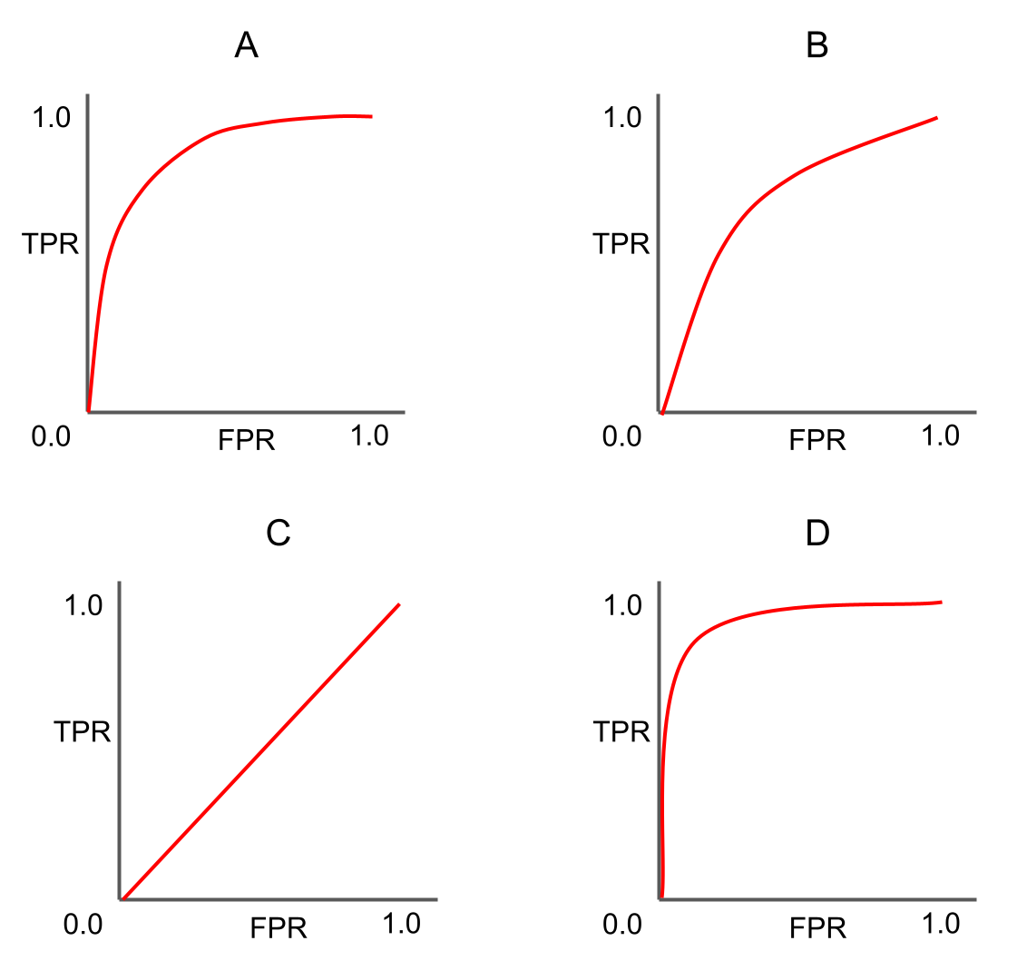

1. A
2. B
3. C
4. **D**

Question

A neural network (the ones we've looked at so far in the course) is probabilistic.

1. True
2. **False**

Explanation: The output of a neural network is always the same so long as the input stays the same.